Education in Peace through non-violent inner dialogue

Thank you to the organisers of this symposium for inviting me to share with you the methodology for peace education that, with CommunicActions (the international school I founded), I have been offering for thirty years as well as to various socio-economic and cultural groups around the world, particularly in 15 countries: mainly in the Great Lakes region (Rwanda, where I was born, Burundi and Eastern Congo) and also Mauritius, in the Indian Ocean.

Since the main obstacles to peace, as well as the most decisive transformations, reside within hearts and minds, the primary resource for peace is true, authentic communication that can unlock human blockages. It is by empathising deeply with what is important to each person (their experiences and needs, foundations, motivations, deep intentions, and most cherished spiritual values) that relationships improve and a sincere connection is created, making the rest of the peace process possible. Yes, but such quality listening is all the more possible and fruitful when dialogue is free from power games and hidden agendas. However, empathy alone cannot offer this. That is where two other skills come into play: the most just legal framework and the quiet strength of a negotiator who is immune to power-grabbing tactics aimed at gaining more.

The art of improving the legal framework is a collective challenge: whenever a group is confronted with an abuse of power or, more broadly, with deficient structures or injustices, that group faces the challenge to become more organised and strengthen its cohesion (this is already true for a herd of herbivores facing a hunting predator). The more structured a human group is, the more capable it is of mobilising itself to ensure that the force of law prevails over the law of the strongest. This is the competence of the normative process by which the group establishes the most just rule and agrees on the measures to be taken in the event of non-compliance with that rule. The process of deterrent sanctions, which gives the rule unavoidable weight, makes good behaviour more attractive than unacceptable behaviour, which is outlawed. The more lawless the area where I lead training sessions, the more crucial it is to spend time on this skill. This work, which puts an end to impunity, begins in families and schools. Before it can be established at a higher level of society, parents and teachers must learn to replace punishment-repression (the law of the strongest) with sanctions-reparation (the force of law).

Alongside authentic communication and a legal framework, a third skill is essential for constructive conflict resolution: the art of effective negotiation. This avoids the pitfalls of rivalry and competition when interests diverge, and is capable of thwarting destabilisation techniques, unfair tactics, grandstanding, dirty tricks, etc. The more one has learned to stay focused on the interests at stake, and to use creativity for coming up with new solutions, the more one can initiate and maintain a win-win process: optimising the most relevant and sensible agreement, i.e. the one that best satisfies all the interests at stake.

Empathy towards people in order to connect with the treasure they carry within them AND fairness in terms of a legal framework that prevents any abuse of power AND creativity in the win-win process that thwarts power plays while increasing the pie to be shared: these are three very different energies, each to be deployed in its own sphere. For example, it is important not to reframe when listening deeply. What invigorates true, sincere and authentic communication is the quality of connection: one human being welcoming another human being. Therefore, at the stage of dialogue where we seek to understand each other, a parent, teacher or manager would do well to completely remove their authority cap, which does nothing to help us understand the other person's treasure; on the contrary, it creates interference that blocks it. There will be other times to reframe (objectify) and negotiate (agree and decide). Another example, in the other direction, is that empathy and trust in people are not the right tools for improving the legal framework. Fair authority is exercised in a depersonalised manner, without any power over people; it serves Law and Order, limiting itself to being fair, i.e. guardian of the law, ensuring that it is respected by all, including the highest-ranking individuals. On the other hand, authoritarian figures personalise power: ‘I am the law; you obey me’. And they will subtly appeal for allegiance to themselves rather than to the law.

Authentic Communication (abbreviated below as AC), Framework of Law (abbreviated below as FL) + Effective Negotiation (abbreviated below as EN): it is important to first of all learn to carefully distinguish between the terms, and then to articulate them.

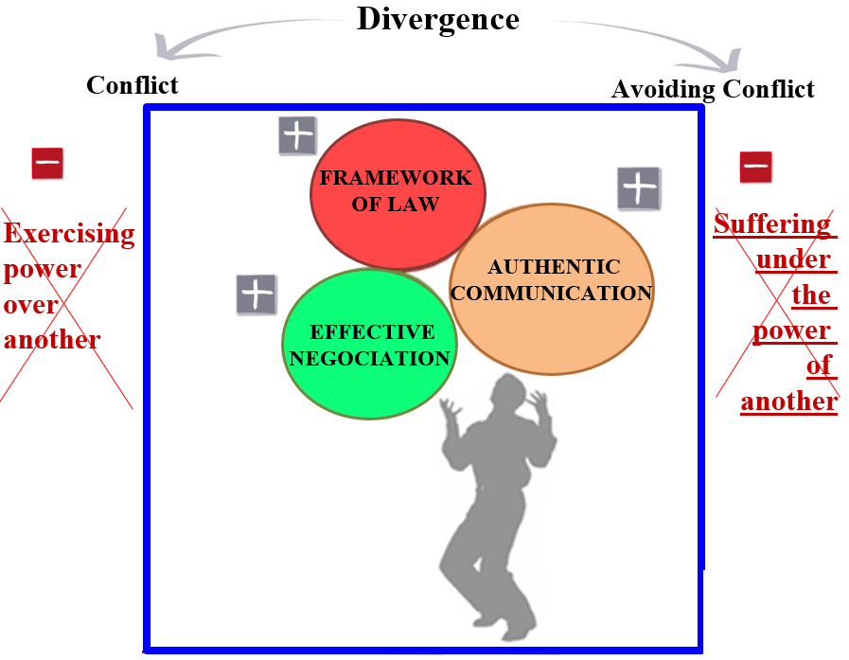 Fig. 1

For teaching purposes in my sessions, I have developed a conceptual model that clarifies the issues at stake, and above all, proposes a roadmap:
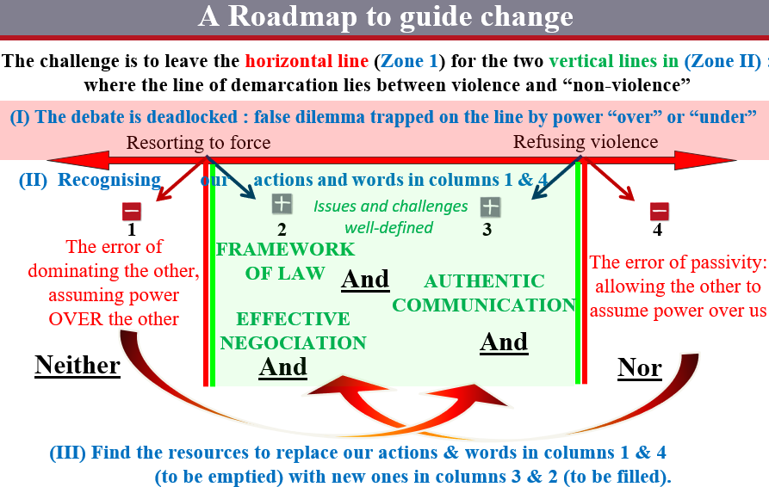Fig. 2

In Zone (I) of the diagram, the horizontal line visualises the gangrene of power of some individuals OVER others: the more authoritarian and dominant my actions and words are, the further to the left of this axis they fall; conversely, the more I submit to your power / the more I let you take power over me, the further to the right of this axis my attitudes fall.
This horizontal line presents the debate as being confined to a single axis, and it is also poorly defined due to the ambiguity of the terms ‘use of force’ and ‘rejection of violence’, which can create misunderstandings as long as their respective truths and errors are not clarified.
It is necessary to move away from the false dilemmas in zone (I) and work more intensively in zone (II), around the two vertical bars. Level (II) clarifies the issues: neither column 1 (domination) nor column 4 (passivity) are the right choices. And for column 2 and column 3, the ingredients of good conflict management are a FL and a EN, within an adjusted AC.
Level (III) outlines the steps of the roadmap, identifying how to empty column 4 to fill column 2 and how to empty column 1 to fill column 3. This model has the benefit of organising the discussion, but above all, the reason I created it is for its practical value in facilitating change. At level (III), we develop an action plan, through which participants gradually transform their counterproductive reflexes (spontaneous attitudes in columns 1 and 4) into skills consciously acquired within the framework.
Learning how to abandon counterproductive power play strategies is an art that can be learned: power is domination when it is power over others; it is a source of progress when, on the one hand, it is power to guarantee justice (FL) and achieve the right objectives in a relevant way (EN), and on the other hand, it is power with others (AC), turning them into allies rather than enemies. It is by no longer submitting to the power of a dominant figure that actors can bring out the best in themselves in overcoming a crisis.
The training course I offer ideally spans several months, giving participants time to acquire these three skills through numerous exercises and progressive training: building a FL capable of sidelining power games, developing an AC that enables relationships based on respect for everyone's needs, and moving beyond competitive opposition through a EN Win-Win process. The following diagram summarises how I move the issue from two to three terms:
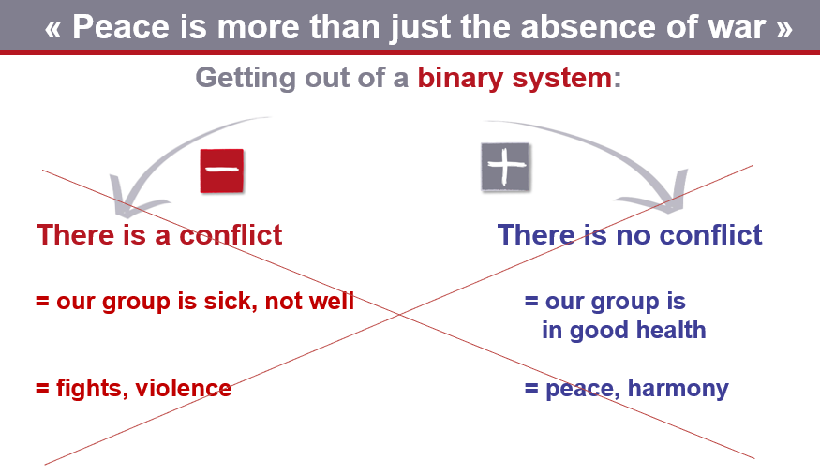 Fig. 3

Between avoiding conflict and mismanaging conflict, there is a much better option: well-managed conflict, which is able to avoid degenerating into power struggles and violence. This ability to dare to engage in conflict in order to avoid violence can be learned!
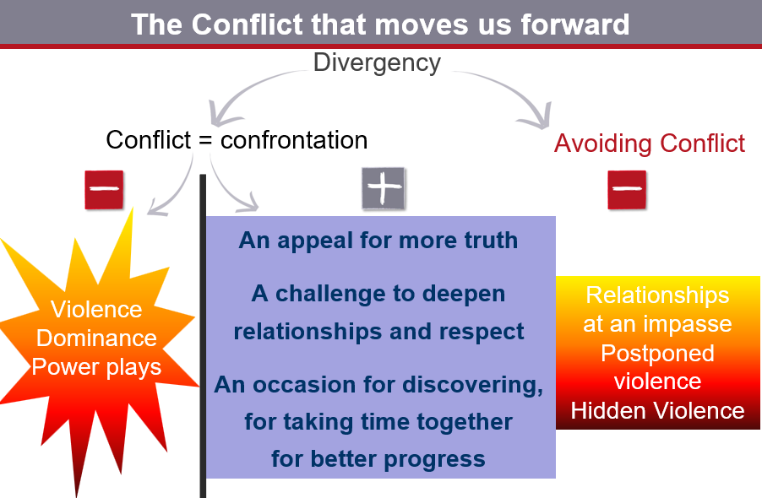 Fig. 4

Just as one learns to juggle three balls by starting with two, participants in my workshops progress from three to four, and then to five terms, following the steps outlined in the diagrams below:
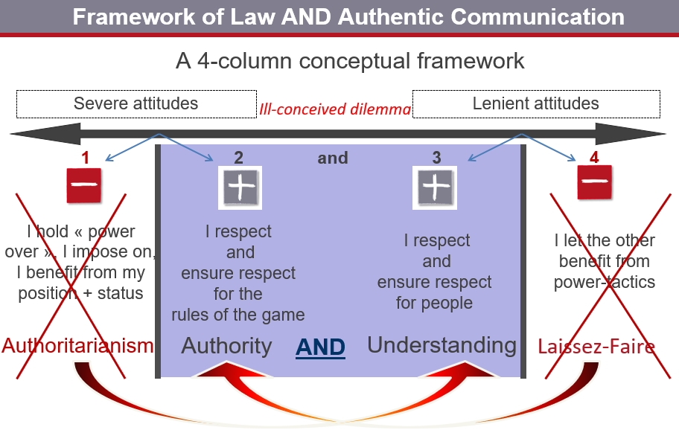 Fig. 5

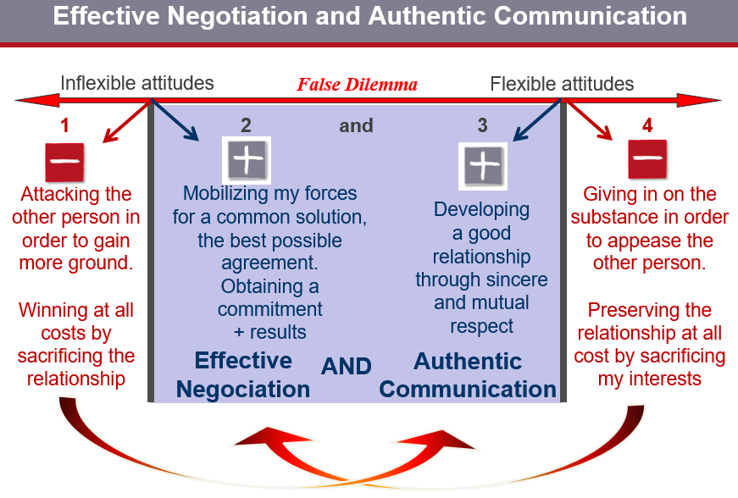 Fig. 6

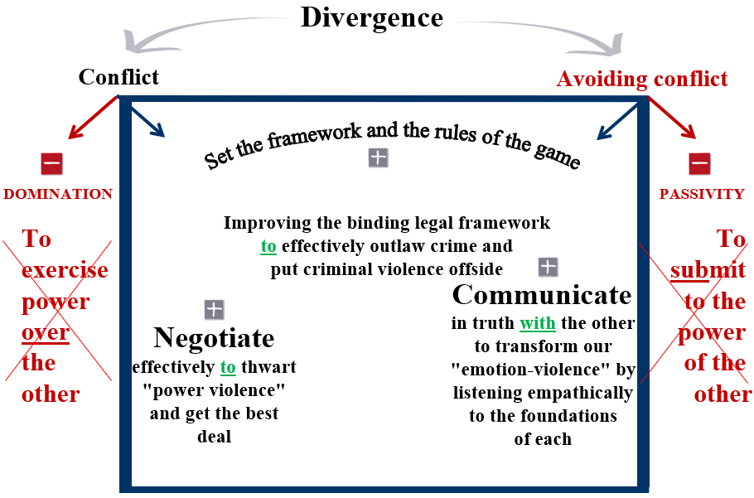Fig. 7
At the interpersonal level, I developed the C-R-I-T-E-R-E method, which proposes seven steps for resolving any interpersonal conflict):
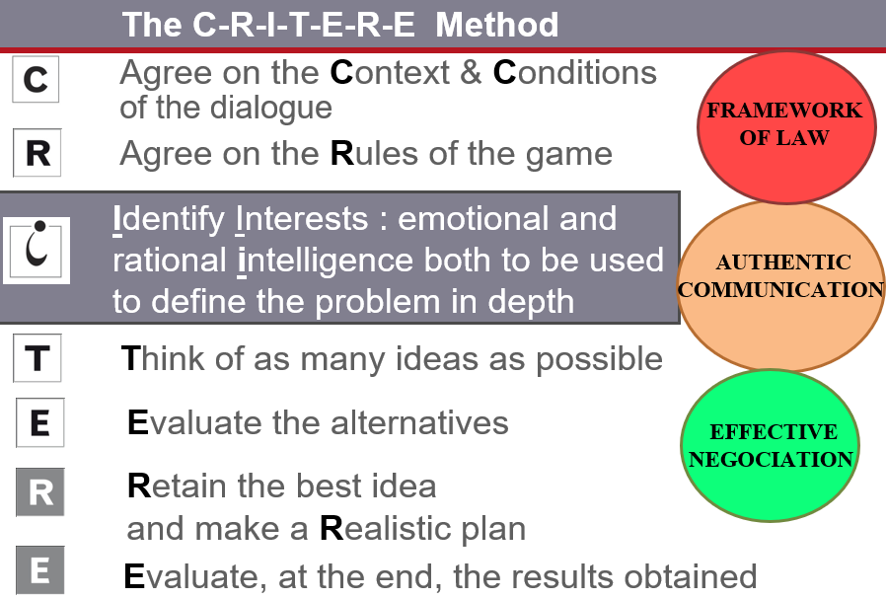 Fig. 8
Some participants continue on the path of (trans)formation with the D-I-A-P-O-S method: how to overcome injustice, right up to the socio-political level:
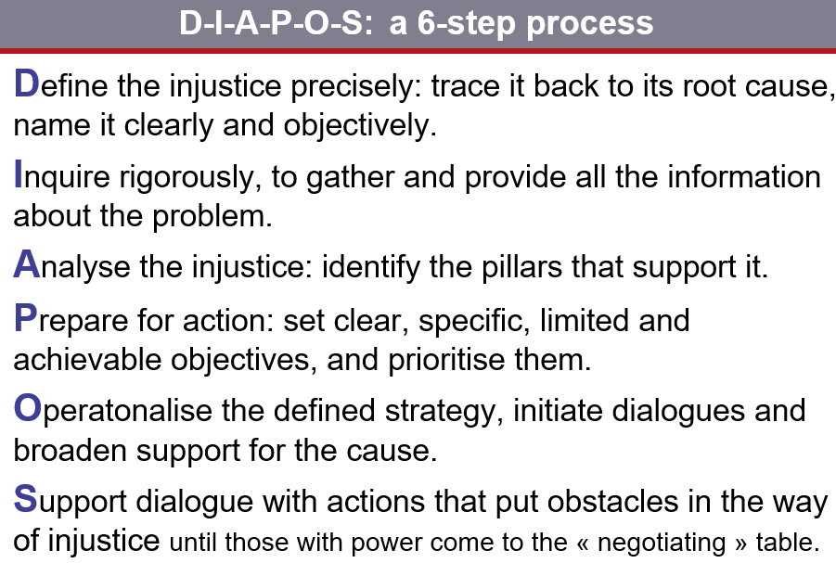 Fig. 9
This begins by leaving behind the false dilemma between revolutionaries and pacifists:
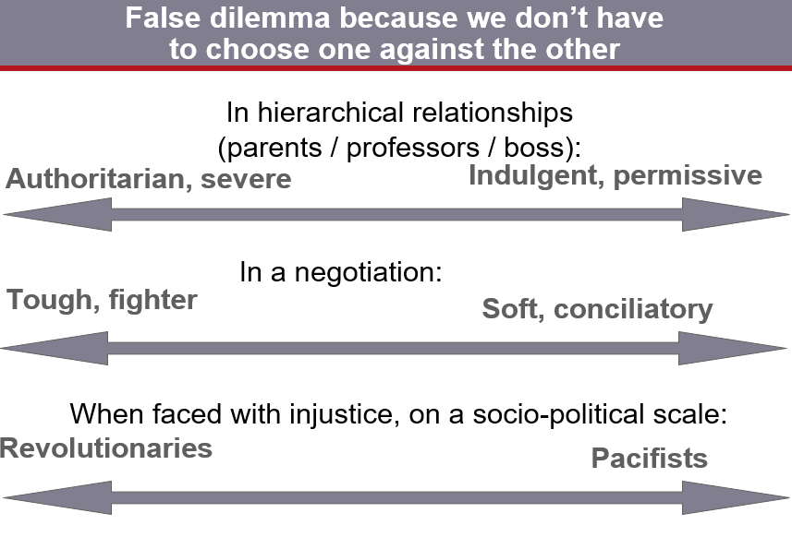 Fig. 10
... and also by breaking free from our various forms of passivity, which contribute to the unjust status quo:
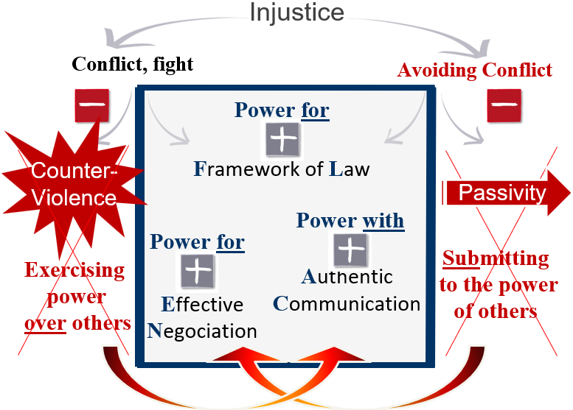 Fig. 11
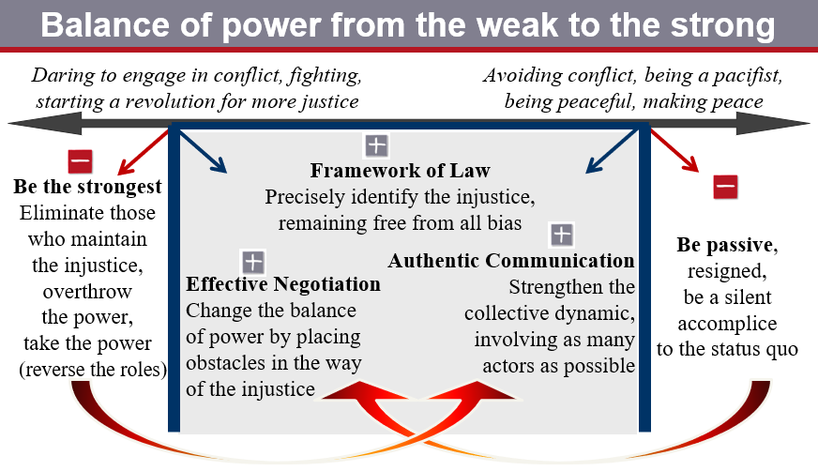 Fig. 12
After this general overview of the programme, we will now examine the resources of empathy in AC, which are first deployed in non-violent internal dialogue. The rest of this article is devoted to these resources.
Across the continents, I have noticed that participants in my sessions have the same reflex when they are invited to present conflictual situations: they do not spontaneously talk about themselves; they talk about the person who said something that sticks in their throat, who “gets on their nerves” and/or keeps them awake at night... When we fixate on the person who has hurt us, the first step we need to take is to untangle each person's part, then, let go of the other person's part and then make an appointment with ourselves to take care of our own wounded part.
Instead of focusing our attention on others and looking for what is wrong with them, we have the freedom/responsibility to listen to the part of ourselves that is affected. Psychologist Richard Schwarz, founder of IFS (Internal Family System) psychotherapeutic process, proposes a protocol for inner dialogue based on our ‘Self’, which he defines as that space of integrity, intact, unharmed by life, where calm, confidence, compassion, curiosity, creativity, courage, clarity and connectiveness (the ability to connect) reign supreme.
From this space-source within us, we can learn to practice a culture of hospitality towards the wounded part of ourselves, engage in genuine dialogue with it, listen to it, take into consideration what it tells us about its experiences, its needs, its motivations...
As angry or depressed as a part of us may be, and even when it seems to take over our entire being, it is not the whole of us. If, from the bottom of our hearts, we treat this part with respect, it will detach itself, dis-identify itself, and separate itself from us. I am me and it is it; it is a sub-personality of mySelf, it is only an incomplete and biased part of my life.
As long as I do not recognise it within my inner family, it risks being like a child craving attention, who makes a lot of noise, demands to be at centre stage, tugs at mother's skirt, and is even capable of misbehaving and getting punished in order to get attention, even negative attention. On the other hand, just like a child who has received the attention it needs, and then goes back to playing quietly in a corner of the room, a part of me can agree to step aside and let me go deeper within myself to encounter my deepest truth.
On this inner journey, our physical sensations and emotions are precious gifts, reliable messengers whose role is to lead us to where there is a blockage or imbalance within us, so that we can take care of it. It is by gently considering the knots in the stomach of our psychic life that we can free ourselves from our judgments, reproaches and the reflex of controlling others; these three types of relational poison are the bitter fruit of poor relationships within ourselves. We can leave them behind all the more easily when, with curiosity, we uncover (remove the cover from) our own core beliefs and deep motivations. In this inner ‘treasure hunt’, feelings serve as signposts to a need that is suffering. The knots in our guts unravel as we offer a presence full of respect for each part of ourselves.
A decisive point in the taming of our psychic life concerns the parts of ourselves that we consider ugly, those we are ashamed of, those we sometimes fight with all our spiritual strength. We love and highlight our bright sides, our Dr Jekylls, and we lock away our Mr Hydes, as far as possible, in the depths of our cellars in the hope of getting rid of them. We judge them to be all the more dangerous because they seem uncontrollable, when in fact they behave in an all the more uncontrollable manner because they are condemned and repressed, just like a child rejected within a family.

A Copernican revolution occurs when we stop fighting a part of ourselves and learn to distinguish that part from its actions. Even though the actions may be horrible, the part itself has positive intentions. It needs security and kindness to reveal why it behaves in this way. According to the IFS model, the ‘managers’ who control (sometimes tyrannically), or the ‘firefighters’ who seek to extinguish the fires (escaping into alcohol, drugs, pornography, binge eating, workaholism, talking too much, over-activity, or the opposite, anorexia, etc.) are like big brothers/big sisters; their role is to protect a little one in the inner family, an “exiled” part that will only be able to tell its story and its tormented truth to the “Self” after the big brother has agreed to step aside. And he will only do so after being understood in his role as protector, and honoured in his skills. It is through this benevolent process that a part of ourself can agree to review its behaviour. We can ask it to let go of a harmful compulsive act, seeking together an alternative strategy that is less socially problematic, and then, the part can adopt this strategy because it allows it to continue its inner role of protection.

« Man is neither angel nor beast ». Those who play the angel become the beast; those who repress their Mister Hydes condemn themselves to suffer them at the worst possible moments. Conversely, those who can offer to their seemingly hideous sides calmness, gentleness and curiosity will find a path to freedom (the gears that mesh within them will cease to be in automatic mode; their parts can let go of their compulsive reflexes and stop intervening against their will). They will also find a path of inner unity (their Dr Jekylls and Mr Hydes can smoke a peace pipe together). In the absence of the deficient ‘Self’, each part plays its part alone. On the other hand, cacophony can become symphony in the presence of the Self, when it plays its role as conductor. As our parts are understood in their needs and thus take their rightful place in the orchestra, the path that leads to the heart of our heart becomes uncluttered. A part that takes a step aside is like a previously closed door that opens, giving access to more intimate rooms in the inner castle (in the words of Teresa of Avila), or like a rolling rock that ceases to obstruct the spring and allows it to flow more freely (like in Ezechiel 47, 1-12). This is the virtuous circle of kindness: initially, the parts need our kind consideration in order to be unblocked. Conversely, our capacity for kindness is strengthened as access to the source becomes clearer. The first movement of human authenticity, which stems from the violence we are capable of when we are hurt, leads us from the outside to the inside. The challenge is to honour the warning lights that flash within our body, heart and guts, the three gateways to the soul. This long inner journey gradually leads us to the natural place of goodness and generosity within us, where the springs of living water flow. The second movement goes from the inside out: the inexhaustible and abundant source of Love that flows within us at the heart of our hearts can then authentically nourish each part of us that suffers from a lack of recognition. This double movement implies two starting points: 1) that of our humanity, humbly taking seriously the messy gook of our conflictual relationships, which contains our most precious gems, 2) that of our soul, which chooses, in free and responsible consciousness, to dive into the shadows of ourselves, where we can have the most enlightening encounters.
This journey, through which we come to terms with our humanity in its depths, bears fruit on three levels: freedom, inner unity, and fraternity. Let us now explain this third aspect, that of better dialogue with others. When we are hurt, the ability to translate our own judgments and reproaches into personal treasure also teaches us to develop empathy capable of listening to others in the right context, that is, when they themselves are hurt: it is to not hear the judgments and reproaches they express about others, but to listen to what they are saying about themselves through what they say about others. Instead of falling into the usual traps of communication, we must resolutely go fishing for their own treasure, upstream from their poisonous actions or words.
Here is an illustration of this, which falls within the intercultural sphere. One of my friends was born to Rwandan parents in Belgium in the same year as I. He has black skin and has always lived in Brussels, never in Africa. He takes the metro every morning to go to work. Each time, he has to endure the stares of Brussels residents who seem to be saying to him, “Where are you from?”, implying, ‘You're not from here; go back home.’ My friend's reflex is to hold their gaze, to challenge them, to tell them, sometimes without words, sometimes with angry looks, that he was born here, that he is Belgian by right and in every sense, that they are wrong and that they would do well to realise how unacceptable their racism is. These experiences disgust him. He lives the deep pain that he will never be seen as fully belonging here. I can sympathise with his suffering, having experienced the situation myself, in the other direction, when I was in my native African country and people laughed in my face when I said I was from there.
In truth, the integration of our multiple identities does not depend on how others view us, but rather on the meaningful encounters we have with our own inner family. We will always encounter incomprehension from others regarding our multicultural identity. Anger and hatred, however, are the bitter fruit of poor relationships within ourselves, which are entirely within our control. When we are overcome by anger (or anxiety, sadness, etc.), we can welcome this angry part of ourselves from the depths of our hearts, listen to its need for justice and its need for respect for its own personal space, and then, gradually uncover other wounded parts that are more fragile and hidden deeply within us. Each time, it is necessary to offer them understanding and tenderness, to meet their need to be accepted, to offer them this acceptance from the depths of our hearts until we finally connect with, and fulfil our need to accept ourselves as we are, until we are fully reconciled with our own complex multicultural history.
The process is not intellectual, limited to verbalisation; it is a matter of emotional intelligence, fuelled by gentleness. It is an inner unfolding through which a stunted part of ourselves (often only a few years old) can finally live fully, in the light of love. It will then be able to take its rightful place, and nothing but its rightful place, within the inner family... This inner process is capable of deactivating the wounds that were previously caused by the gaze of others, leading to true peace.
The peace we make within ourselves gives us the gentle energy to make peace with others, offering them a space free of judgment, in which they can experience benevolent acceptance of their own wounded history and their own plural identity. The remedy for the violence caused by our painful experiences is non-violence, in this sense: respect and consideration, made possible because at the very heart of every human being there is a source which lies beyond our cultures and religions. This place is given to us naturally. My experience in the sessions that I give all over the world is that, regardless of people's religion or culture, they can tame their humanity, discover and practise a culture of hospitality towards the wounded parts of their inner family and, from there, toward those parts of their outer families.
This is the good news about authentic communication. Of course, this skill is not the only one required for constructive conflict management. Before authentic communication can take place, the legal framework must be in place to create the conditions for dialogue, free from power games, manipulation and hidden agendas. And beyond genuine communication, there is effective negotiation that frees us from our instinctive desire to pull the blanket over ourselves. When interests diverge, we need the ability to come up with the best solution that satisfies all parties. But the heart of the process is to meet each person in their truth and in the peace they carry within them. False life is exhausting, true life is inexhaustible.

Étienne CHOMÉ (chome@communicactions.org), author of the C-R-I-T-E-R-E method for improved conflict management, and founder of CommunicActions International School (www.communicactions.eu).

